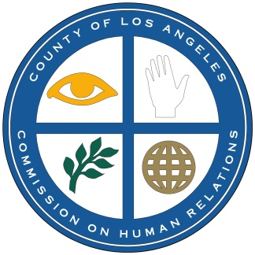 **Los Angeles County**

**Workforce Development, Aging & Community Services –**

**Human Relations Commission**

3175 West 6th Street, Suite 406 (213) 738-2788

Los Angeles, CA 90020

**SAVE THE DATE**

**NETWORK AGAINST HATE CRIME**

**SPECIAL VIRTUAL MEETING**

**THURSDAY, APRIL 29, 2021**

**1:00 P.M. TO 2:00 P.M.**

***WHO WAS BEHIND THE JANUARY 6TH INSURRECTION***

***AT THE U.S. CAPITOL?***

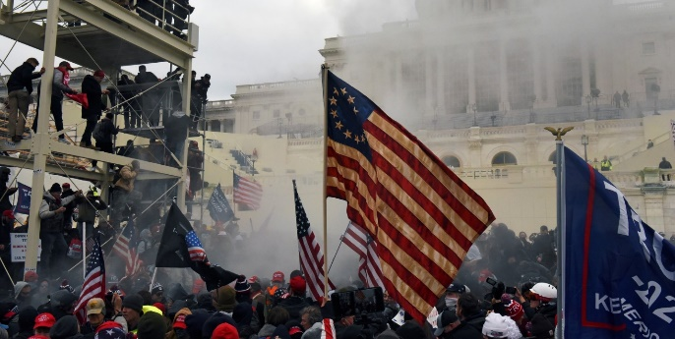

The world watched in horror on January 6, 2021 as thousands of protesters stormed the U.S. Capitol. The mob attempted to overturn President Trump’s defeat in the 2020 election by Joe Biden. Five people died and more than 140 were injured. More than 400 persons have been charged with federal crimes and dozens of those arrested were found to be members of white nationalist groups, including the Oath Keepers and Proud Boys.

Researchers from the **Southern Poverty Law Center** will discuss the organizations and individuals behind this unprecedented insurrection. More details to follow. A link will be sent at a later date.

Please RSVP to Sharon Williams at 213-738-2788 or swilliams@wdacs.lacounty.gov. Please also contact Sharon if you have any questions or need assistance.

We encourage you to allow an extra five minutes to join.